User Manual

Ver. 1

22/04/15

Written by Dylan Gilmour

Contents

Introduction 3

Copyright Notice 3

Game Rules 3

Game Requirements and Installing the Game 3

Minimum requirements 3

Installation 3

The Game Screen 4

Main Menu 4

Player Objects 4

Ball 4

Bat 4

Bricks 4

How to Play 5

Controls 5

Player 1 5

Player 2 5

Scoring System 5

Starting the Game 5

Winning the Game 5

Losing the Game 5

Quitting the Game 5

Help 5

# Introduction

This game was made for submission to Dylan Gilmour’s Graded Unit, as part of his HND Software Development.

The game is in a similar style to the classic “Breakout” which was released in 1972 by Atari Inc.

## Copyright Notice

This game was created by and is the sole property of Dylan Gilmour. All assets used are, unless otherwise stated, also the individual property of Dylan Gilmour.

# Game Rules

1.) The player must hit the ball into the bricks by controlling the bat, in order to earn points

2.) If the player fails to keep the ball in control, they will lose a life

2.2) In Competitive Mode, if one player fails to keep the ball in control, they will lose a life AND the other player will gain 20 points.

# Game Requirements and Installing the Game

## Minimum requirements

|  |  |
| --- | --- |
|  | Minimum |
| Operating System: | Windows XP with SP2 |
| Processor: | 1GHz |
| Graphics Card: | Support for Shader Model 1.1 and DirectX9.0C |
| Memory: | 512MB |
| Sound Card: | N/A |
| Input: | Keyboard |

Systems wishing to run the game will be required to have .Net Framework 4 installed and Microsoft Access or Microsoft Access Runtime.

Microsoft access runtime: <http://www.microsoft.com/en-gb/download/details.aspx?id=39358>

.Net Framework: https://www.microsoft.com/en-gb/download/details.aspx?id=17851

## Installation

Double click the setup.exe and follow the instructions on screen.

# The Game Screen

## Main Menu

This is the main menu of the game.

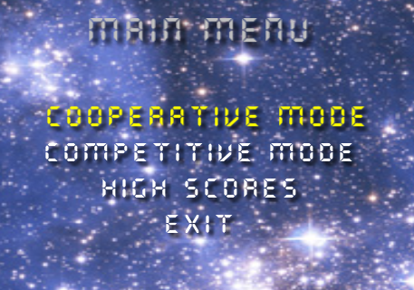

## Player Objects

### Ball

This is the ball which can be seen in-game. The player must keep the ball in control by using the bat.



### Bat

This is the bat which can be seen in-game. The player uses the bat to control the ball in order to hit the bricks.



## Bricks

These are the game bricks, which the player must destroy in order to gain points. Despite being different colours, they all award 10 points.



# How to Play

The player must control a bat in order to keep the ball in play, and they will use the ball in order to destroy bricks, which will award points.

## Controls

The Game can be played using a keyboard.

**Esc** – opens the pause menu

**Enter** – select menu option / changes which high score mode is displayed on the high score screen

### Player 1

**A** – Move the players bat left

**D** – Move the players bat right  
**E** – game start

### Player 2

**Left Arrow Key** – Move the players bat left

**Right Arrow Key** – move the players bat right

**Up Arrow Key** – game start

## Scoring System

Each brick destroyed by the player will award them 10 points.

## Starting the Game

The game can be started by pressing enter on the wanted game mode

## Winning the Game

In competitive mode, the player can win by having a higher score than the other player, once one of them hits 0 lives.

## Losing the Game

The player will lose the game if they lose all their lives.

## Quitting the Game

The player can quit the game by pressing Esc, which will bring up the pause screen, where they can choose to continue or quit the game.

# Help

If the game does not run correctly ensure that the specifications of the computer you are running it on are sufficient to run the xna framework. If the specifications are correct and the game still doesn’t work try reinstalling it.